

NAME : BISMA FATIMA
CLASS : CS A 24
ROLL NO : F24605036
COURSE : DLD LAB
COURSE CODE : CS-131
LECTURER : MISS TEHREEM KHALIL

Lab 03

DIGITAL LOGIC DESIGN EXPERIMENT # 2
INTRODUCTION TO BASIC GATES AND TROUBLESHOOTING

OBJECTIVE:
- To learn and understand the working of basic gates (AND, OR, NOT)
- To learn and understand troubleshooting of logic circuits

APPARATUS: Logic trainer

COMPONENTS: ICs 74LS08, 74LS32, 74LS04

THEORY:
Digital circuits are the electronic circuits that manipulate binary information. Logic gates are the basic building blocks in constructing digital circuits. Logic gate has one output and one or more inputs. Each logic gate performs a specific logical operation. The interconnection between inputs and outputs of gates form a digital circuit. Any digital circuit can implemented using three basic logical operations called AND, OR, and NOT. That is why AND, OR, and NOT gates are referred as basic logic gates. AND OR logic functions exhibit the phenomenon of dominance. In both cases, there is an input value that will force the output of the gate to a known value regardless of the state of other inputs. This value is known as the dominant value of the gate. The dominant value of an AND gate is zero, while the dominant value of an OR gate is one.

In this experiment, we will use 74LS08, 74LS32, and 74LS04 ICs for the implementation of AND, OR, and NOT logical operations. 74LS08 IC contains four 2-input AND gates. The function table and connection diagram for this IC are shown below:
Function Table:

 | Inputs |  | Output
A |  | B | Y
L |  | L | L
L |  | H | L
H |  | L | L
H |  | H | H

H= Logic High, L= Logic Low

Connection Diagram:
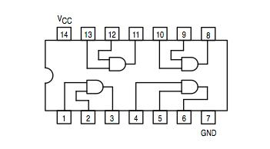

74LS32 IC contains four 2-input OR gates. The function table and connection diagram for this IC are shown below:
Function Table:

 | Inputs |  | Output
A |  | B | Y
L |  | L | L
L |  | H | H
H |  | L | H
H |  | H | H

H= Logic High, L= Logic Low

Connection Diagram:
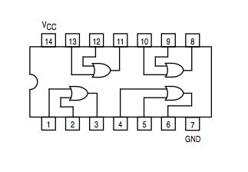
74LS04 IC contains six NOT gates. The function table and connection diagram for this IC are shown below:

Function Table:
Input | Output
A | Y
L | H
H | L

H= Logic High, L= Logic Low
Connection Diagram:
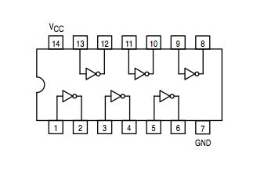
Testing of ICs:
Before starting implementation of a specific logic circuit, all basic gate ICs should be tested in order to make sure that the ICs are working properly. Using the function table (truth table) for each gate, in a particular IC, apply all input combinations one by one and check its output logic level on LED.

Troubleshooting:
After testing all required number and type of ICs we need to implement a digital circuit, we start implementing the circuit on logic trainer. Once we complete the implementation, we need to test the output of the circuit to make sure that whether the circuit is working accurately or not. Using the truth table that represents the functionality of the logic circuit, we apply all input combinations one by one and check its output logic level on LED.

If the output of circuit is incorrect for some input combinations then there must be some fault in hardware implementation of the circuit. The fault can be an open circuit, short circuit, incorrect Interconnection between the gates, incorrect connection with switches etc. Therefore, we need to troubleshoot the circuit. To troubleshoot the logic circuit apply the input combination at which the output of the circuit is incorrect, and then trace back the fault by checking each intermediate connection of the circuit using logic probe. The most efficient way to quickly reach the fault location is to exploit the low logic level dominance in AND gate and high logic level dominance in OR gate.

LAB TASK#1:
Implement the following logic circuit on logic trainer.
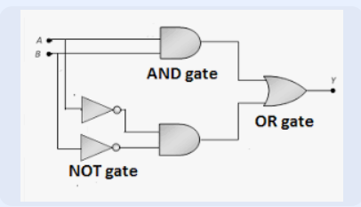

Write truth table in the space provided below:

A | B | A’ | B’ | A.B | A’.B’ | (A.B)+(A’+B’)
1 | 1 | 0 | 0 | 1 | 0 | 1
1 | 0 | 0 | 1 | 0 | 0 | 0
0 | 1 | 1 | 0 | 0 | 0 | 0
0 | 0 | 1 | 1 | 0 | 1 | 1

FIGURE
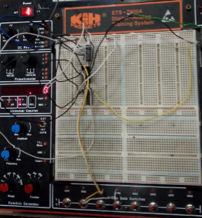

LAB TASK#2:
For the logic circuit given below do the following:
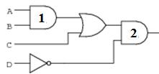
i. If there is a fault in the circuit i.e. output of OR gate is stuck at zero, then predict how the operation of the logic circuit will be affected due to this fault.
ANSWER:
If the output of the OR gate is stuck at 0, it means that regardless of the input values, the OR gate always outputs 0.

Effect on the Circuit:
The AND gate receives one of its inputs as 0, which means the output of the AND gate will always be 0 (since 0 AND anything = 0).
Thus, the final output of the circuit will always be 0, regardless of any input combinations.
Conclusion:
This fault will completely disrupt the circuit’s functionality, making it always output 0.

ii. If there is a fault in the circuit i.e. output of AND gate 1 is stuck at one, then at what input combinations the output would be wrong.
ANSWER: If the AND gate output is stuck at 1, the output will remain 1, no matter what inputs it receives.
Effect on the Circuit:
Since the AND gate should normally output based on its two inputs, this fault means the circuit will always output 1 regardless of the inputs.
This causes incorrect operation in cases where the AND gate should output 0.

Identifying Wrong Inputs:
To find where the output is wrong, we need to determine when the AND gate should be 0 in a normal scenario. The AND gate gives 0 when either of its inputs is 0. However, due to the fault, it is always 1, which is incorrect.

Thus, the wrong output will occur whenever the correct AND gate output should have been 0. That happens when:
1. The OR gate outputs 0.
2. The NOT gate output is 0 (which happens when D = 1).
For these cases, the actual circuit should give 0, but due to the fault, it gives 1, making the output incorrect.

Post lab question:
- Let us assume that the logic circuit given in lab task#2 is implemented on logic trainer and its output is wrong at (0000, 0010, 0100, 0110, 1000, and 1010) input combinations. What can be the fault in the implementation? Give answer with proper reasoning.
A | B | C | D | EXPRCTED OUTPUT | FAULTY OUTPUT
0 | 0 | 0 | 0 | 0 | WRONG
0 | 0 | 1 | 0 | 0 | WRONG
0 | 1 | 0 | 0 | 1 | WRONG
0 | 1 | 1 | 0 | 1 | WRONG
1 | 0 | 0 | 0 | 1 | WRONG
1 | 0 | 1 | 0 | 1 | WRONG

# Step 1: Identify the Common Pattern
The incorrect output combinations are:
(0000, 0010, 0100, 0110, 1000, 1010)
Notice that the last digit (D) is 0 in all these combinations.

# Step 2: Analyze the Circuit Behavior
Recall the circuit implementation:
X = A + B
Y = D̄
F = X * Y
Since the output is incorrect when D = 0, let's focus on the NOT gate (D̄) and its connection to the AND gate.
# Step 3: Possible Fault Identification
Given the pattern, it's likely that the fault is related to the NOT gate or its connection to the AND gate.
One possible fault is:
- The NOT gate is faulty, and its output is stuck at 0.
This would mean that Y = 0, regardless of the input D.
# Step 4: Verify the Fault
If the NOT gate output is stuck at 0, then:
F = X * Y = X * 0 = 0
This would result in an incorrect output for the given input combinations.
The final answer is:
The fault is likely due to the NOT gate output being stuck at 0.

- Implement the circuit on circuit verse/Trainer and draw truth table.

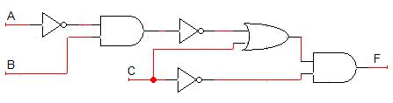

CIRCUIT ON CIRCUIT VERSE/TRAINER
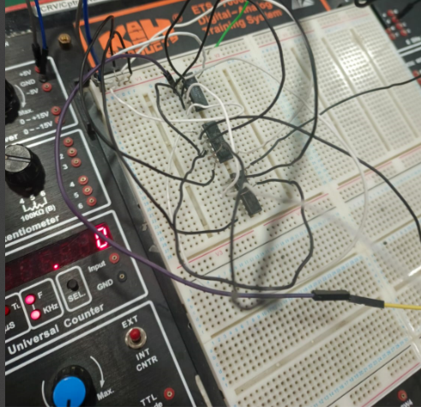

truth table
A | B | C | A’ | A’.B | (A’.B)’ | C+(A’.B)’ | C’ | C’.(C+(A’.B)’)
0 | 0 | 0 | 1 | 0 | 1 | 1 | 1 | 1
0 | 0 | 1 | 1 | 0 | 1 | 1 | 0 | 0
0 | 1 | 0 | 1 | 1 | 0 | 0 | 1 | 0
0 | 1 | 1 | 1 | 1 | 0 | 1 | 0 | 0
1 | 0 | 0 | 0 | 0 | 1 | 1 | 1 | 1
1 | 0 | 1 | 0 | 0 | 1 | 1 | 0 | 0
1 | 1 | 0 | 0 | 0 | 1 | 1 | 1 | 1
1 | 1 | 1 | 0 | 0 | 1 | 1 | 0 | 0

